SATISH CHANDRA MEMORIAL SCHOOL
PERIODIC TEST-I/ PREMID EXAMINATION (2025-26)
CLASS V
ENVIRONMENTAL SCIENCE
Time Allowed: 1 hr 30 min Maximum Marks: 40

General Instruction:
This Question paper contains 7 pages with 34 Questions. All Questions are compulsory.
- Section A: Questions 1 to 20: Multiple Choice Questions containing 1 mark each
- Section B: Questions 21 to 25 are Case Based Questions containing 1 mark each
Questions 26 to 30 are Case Based Questions containing 1 mark each
- Section C: Questions 31 to 33: Subjective Questions: Containing 2 mark each and Question 34 containing 4 mark.

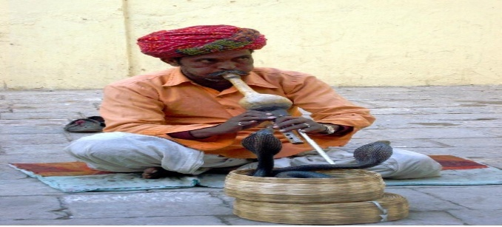
Section A

- Snake dance to the tune of snake charmer because
- They are charmed by music
- Snake charmers flute is very melodious.
- They are trained like other pets
- They change position with the change in position of the flute.
- Statement A- Iodized salt is a good source of Iodine.
Statement B- As it protects from deficiency diseases
a. Statement A is incorrect but Statement B is correct.
  - Statement A is correct but Statement B is incorrect.
  - Both the statements are correct.
  - Both the statements are incorrect.

- Statement 1- Many dogs are trained to work as guide dogs, they rescue people from danger.
Statement 2- Sense of smelling is not strongest in a dog.
  - Statement 1 is incorrect but Statement 2 is correct.
  - Statement 1 is correct but statement 2 is incorrect
  - Both the statements are correct
  - Both the statements are incorrect.

4. Observe the three groups of foods and choose the correct components of food from the option given below :
GROUP A | GROUP B | GROUP C
Wheat, Rice, potatoes | Milk, fish, peas, soya bean | Burger, pizzas, chips, soft drinks

  - Group A – Carbohydrate, Group B –Fats , Group C – protein
  - Group A- protein, Group C – carbohydrates, Group B – Fats
  - Group B – protein , Group A – Fats , Group C – carbohydrate
  - Group A – carbohydrate, Group B – protein , Group C – Fats
5.Name the preparation technique of Mamidi tandra after adding sugar and jaggery into the mango pulp
      - Boiling
      - Sundry
      - Baking
      - Frying

  - Statement- ORS are given when anyone suffer from diarrhoea and dysentery.
Reason- It helps to restore Water loss
      - Both the statement and reason are correct.
      - Both the statement and reason are incorrect.
      - Statement is correct but the reason is incorrect.
      - Statement is incorrect but the reason is correct.

  - Statement 1 - Paheli is thinking that mango pickle that her grandmother makes does not gets spoiled for long time.
Statement 2 - Common salt is used as preservative.

          - Statement 1 is correct but statement 2 is incorrect.
          - Statement 1 is incorrect but statement 2 is correct.
          - Both the statements are correct.
          - Both the statements are incorrect.

8. The inventor of Velcro is
A. Albert Einstein
B. Doctor Beaumont
C. Alexander Fleming
D. George Mestral

9. Match the following-
(i) Russel's viper | 1. Non poisonous snake
(ii) Python | 2. Hollow teeth of snake
(iii) Fang | 3. Poisonous snake
(i) (ii) (iii)
a. 3 2 1
        - 3 1 2
        - 1 2 3
        - 2 3 1

10.Vinay’s mother told to bring a packet of bread from the nearby market what are the following things Vinay need to observed while buying bread packet
a. Expiry date
b. Weight
c. Manufacture date
d. All of these

11.Jim Corbett National Park is in ________ and Bandhavgarh National Park is in _______.
      - Uttar Pradesh, West Bengal
      - Madhya Pradesh, Himachal Pradesh
      - Uttarakhand, Madhya Pradesh
      - Andhra Pradesh, Kerala

12.Statement1 : In Indigestion, the food is not properly digested leading to a feeling of illness.
Statement 2: Indigestion is due to anxiety, food poisoning, spicy food, overeating .
- Statement 1 is correct but statement 2 is incorrect.
- Statement 1 is incorrect but statement 2 is correct.
- Both the statements are correct.
- Both the statements are incorrect.

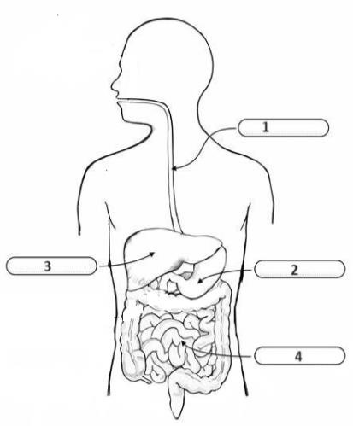

13. Choose the correct labelling of the diagram
1 2 3 4
  - Oesophagus Stomach Liver Large Intestine
  - Wind Pipe Liver Intestine Stomach
  - Oesophagus Pancreas Appendix Intestines
  - Oesophagus Stomach Liver Small Intestine

- Statement : Project Tiger was initiated in 1972 by the Indian government to protect Bengal tigers and their habitats.
Reason: The project aimed to establish dedicated tiger reserves and enhance tiger populations
- Both the statement and reason are correct.
- Both the statement and reason are incorrect.
- Statement is correct but the reason is incorrect.
- Statement is incorrect but the reason is correct.
15. Which part of the plant produces pulses?
a. Leaves
b. Roots
c. Stem
d. seed
16. Statement :Seed dispersal ensures that plants grow in a variety of habitats and prevents overcrowding.
Reason: Seed dispersal mechanisms help plants spread to new areas and avoid competition with their parent plants for resources.

    - Statement is wrong but reason is correct.
    - Statement is correct but the reason is wrong.
    - Both the statement and reason are correct.
    - Both the statement and reason are incorrect.
17.Statement :Freezing is a method of food preservation.
Reason : Freezing inhibits the growth of microorganisms and slows down bacterial activities.
- Statement is wrong but reason is correct.
- Statement is correct but the reason is wrong.
- Both the statement and reason are correct.
- Both the statement and reason are incorrect.

18. Coconut seeds are primarily dispersed by
a. Wind
b. Water
c. Animal
d. None of these
19. Beri Beri is caused due to the deficiency of_______.
a. Vitamin A
b. Vitamin B1
c. Vitamin C
d. Iron
20. Statement: Snakes are considered a friend of farmers.
Reason : They mostly feed upon rats which in turn feed upon the plants or grains.
- Statement is wrong but reason is correct.
- Statement is correct but the reason is wrong.
- Both the statement and reason are correct.
- Both the statement and reason are incorrect.
Section B
CASE STUDY-1: (For Q.21 to Q.25)
Mangoes hold a special place in our hearts and on our plates. The mango season in India typically begins in March and extends until the end of June, marking a time of joyous indulgence. From bustling markets to roadside stalls, the air is filled with the sweet aroma of ripening mangoes. Varieties such as Alphonso, Banganapalli, and Himsagar grace our tables, each with its unique taste and story. We love mangoes not just for their delectable taste but for their versatility in our culinary traditions. Whether it’s a chilled glass of aam panna to beat the summer heat or a bowl of creamy mango kulfi to end a meal, mangoes bring happiness in every bite.
21.Which state is famous for the Himsagar Mango?
A. Uttarpradesh
B. Karnataka
C. Gujarat
D. West Bengal
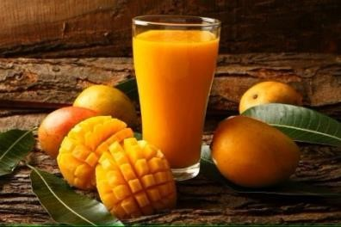
22.What is the typical season for Mangoes in India?
A. December to February
B. March to June
C. July to September
D. October to December
    - Statement- The most ripen mangoes are chosen for making MamidiTandra.
Reason - Mangoes that are ripen consist of more juice and less fibre
- Only the statement is correct.
- Only the reason is correct
- Both the statement and reason are justified.
D. Neither the statement nor the reason is justified
24.Why was sugar and jaggery mixed into mango pulp and dried in the sun?
25.What things are made from ripe and unripe mangoes?
Case study 2 (For Q.26 to Q.30)
The number of tigers and many other animals in our country is reducing . There is a danger that some of them will soon disappear . To protect the animals our government has made some forests as protected areas .
26. The animals that are on verge of becoming extinct are called ___________. (1)
27.Name any 2 extinct animals. (1)
28. write any one step taken by government to protect animals . (1)
29. As the number of tigers are decreasing day by day what are the dangers to tigers in the jungle ? Choose and write the correct answer. (1)
- Hunter b) Poacher c) Imbalance in nature due to human activity d ) All of them
30. write true or false for the following statements . (½+1/2)
a) A tiger roar can be heard from 4 kilometres away .
b) Tigers have sharp sense of hearing.
Section C
Q.31. When food gets spoiled it produces foul smell along with sour order .In which seasons do food items gets spoiled quickly and why? (1+1)
Q.32. A diet that comprises of right amount of all nutrients that we required in a day is called balanced diet . (1+1)
a)What happens if our food is not balanced with proper nutrients?
b) Rita has difficulty in seeing in low light and darkness. Doctors suggested her to take foods like carrots and yellow vegetables with meal . can you name the disease she is suffering from and also write the cause for this disease .
Q.33. Observe and follow the given diagram and answer the following (1+1)
a) why ants always move in straight line ?
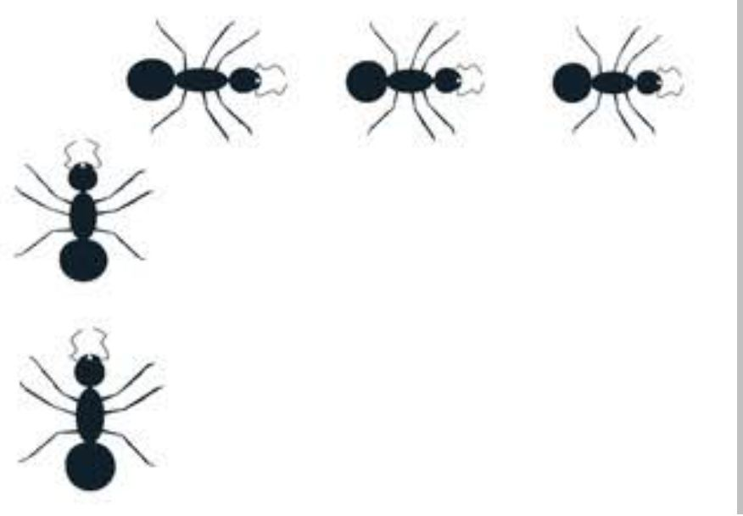
b)Do you think ants have any super sense explain your answer .

Q.34. a) Some people dislike certain food while others enjoy them. How do we experience different tastes? (1)
b) With the help of diagram of a tongue show the location of four taste receptors in human being. (1+2)

___________________________

